WRITING
A PRODUCTIVE SKILL
CONTENTS
Survey – Mindmap | 2
Survey – ways of written practice – mindmap | 3
Differences between written and spoken English | 4
Reasons for teaching writing | 7
Characteristics of written language | 8
Types of classroom writing performance | 9
From copying to free writing | 11
Ways of written practice | 12
1. Copying | 13
2. Intensive writing, controlled writing | 15
Guided writing | 17
3. Self writing | 25

Some thoughts on teaching writing – Differences between written and spoken English
How is writing like swimming? Give up? Answer: The psycholinguist Eric Lenneberg (1967) once noted, that human beings universally learn to walk and to talk but that swimming and writing are culturally specific, learned behaviours. We learn to swim if there is a body of water available and usually only if someone teaches us. We learn to write if we are members of a literate society. And usually only if someone teaches us.
Writing is sometimes regarded as the 'forgotten skill'. Arguably, writing receives the least attention because it is at the bottom of the list of teachers' priorities. With limited classroom time and limited time for correction of written work, anything more than a piecemeal approach will both occupy time that could perhaps be spent on more immediate linguistic needs and, perhaps more crucially for many teachers, make excessive demands on their preparation time. In addition, in the perception of many learners, writing in English is not within the scope of their purpose of attending a language course in the first place. With its associations of homework, written exercises and examinations, writing may seem both 'traditional' (in the negative sense of the word) and irrelevant to learners' immediate needs. From a purely pragmatic point of view, they may not view time spent writing in class as time well spent, preferring the time to be spent on more active aspects of language learning. Like reading, writing is generally a silent, reflective activity and silence is not something that learners (and many teachers) generally associate with a language classroom. Likewise, many teachers may regard writing as some-thing that 'takes care of itself, a side issue that is best taken care of in the form of an occasional homework task. In short, writing gets a bad press, particularly in relation to the other productive skill, speaking.
If we consider some of the reasons for negative attitudes to writing in relation to speaking' some of the following issues emerge:
Feedback on oral production can be instant (correction of errors of syntax, pronunciation and so on). Such interaction in class can be motivating, lively, even fun. Error correction may come from the teacher, from other learners or from the speaker himself or herself If such classroom interactions are skillfully managed, the oral element can be clearly seen to have a direct relationship with performance and improvement.
Feedback on written work, by contrast, usually lacks this sense of immediacy. Error correction comes later, often days or even weeks later, when the original task may no longer have much relevance to the writer. Even if it does come within a single lesson, if correction of the written work is carried out by the teacher, there will necessarily be an interval where the teacher is involved in the correction, and his or her involvement with the learners is consequently reduced. This will often lead to a quiet period when learners are, perhaps, reading or doing more writing. The effect on pace and classroom dynamics can be negative. The hustle and bustle of the 'market-place' of oral interaction and correction is lost.
With written work, correction will tend to come from the teacher. Peer correction, though possible, is, from a practical point of view, often less easy to manage and may not be widely used as a consequence. Simply returning the text to the learner with all the corrections made can have the same effect on the learner as the kind of oral correction where the teacher simply repeats the correct form each time without giving the learner the chance to self-correct. Except in the case of the most committed learners, written work returned to the learner with all the corrections made by the teacher is likely to finish up fairly quickly in the nearest waste receptacle, the learner pausing only to see what mark has been awarded or how many ticks there are on the piece of work concerned. Self-correction of written work seems to be the most favoured method, since it involves more self-discovery and trial and error on the part of the learner, but it also demands a great deal of application. Rewriting the same text following a scheme of error notation introduced by the teacher is, no doubt, extremely beneficial. However, it lacks the freshness of, say, trying to express something orally in a different way, having made an error or errors the first time. Since such rewriting may demand two, three or even more attempts, the question of motivation and application is a central one. By the fourth time of writing, the text may be as unappealing as a sentence repeated orally by the learner ad infinitum until the teacher accepts it as 'correct'.
Many learners simply find writing more difficult than speaking. Of course, this is not true for all learners and there are certain cultures, Japanese, for example, where more emphasis is placed in education on the written word and this, combined with cultural restraints on taking the initiative in conversation, can lead to the impression that such learners are much better at writing than at speaking. For the most part, however, the opposite is the case and writing is associated with difficulty. One of the major reasons for this is that written discourse, almost by definition, requires a greater degree of formal accuracy than oral discourse. Whereas a learner may be able to get his or her message across relatively successfully in an oral form, despite making a number of grammatical, lexical, syntactic and phonological errors, the same message in written form would generally be regarded as unacceptable, even incomprehensible, if accompanied by a similar number of errors (the phonological errors being replaced by corresponding errors of spelling and punctuation). More accuracy is demanded and this may be as frustrating for many learners keen to express themselves fluently in written form as it is for learners struggling to communicate orally and being constantly corrected. The need for accuracy also means a far greater amount of time is needed. Spontaneous writing, unlike spontaneous speaking, tends to be relatively rare. Native speakers constantly make "mistakes' when they are speaking. They hesitate and say the same thing in different ways and they often change the subject of what they are saying in mid-sentence. Except in extremely formal situations this is considered normal and acceptable behaviour. A piece of writing, however, with mistakes and half-finished sentences, etc. would be judged by many native speakers as illiterate since it is expected that writing should be 'correct'. From the point of view of language teaching, therefore, there is often far greater pressure for written accuracy than there is for accuracy in speaking.
Preparation time is needed, as is follow-up time, probably involving self correction of some kind. The whole process seems more time-consuming, more demanding and, possibly, less rewarding.
The above argument rests on the basic premise that writing, as part of the language-learning spectrum, is an area where tasks are set, written and corrected (either by the teacher or by the learners), and where accuracy of written form is the ultimate goal. Writing of this kind is generally regarded not as an end in itself, but as a means of practicing language items and, ultimately, as a means of testing all-round language proficiency.

A speaker has a great range of expressive possibilities at his command. Apart from the actual words he uses, he can vary his intonation and stress, which helps him to show which parts of what he is saying are more or less important, or whether, for example, he wishes to be taken seriously.
At any point while he is speaking he can re-phrase what he is saying or speed up (or slow down) depending on the feedback he gets from his listeners. People listening to him can show by a variety of means that they do or do not understand/approve of what is being said, and of course the speaker can use facial expression, gesture and body posture to help to convey his message.

Of course these points are especially true of a speaker involved in a conversation, where other participants can interrupt, ask for clarification or give other types of feedback. The speech maker, however, may not be asked for clarification, but he will still learn a lot from the attitude of his audience. Speaking on the telephone obviously does not allow for the use of facial expression or gesture, but intonation and stress are used to great effect as well as rephrasing, etc.
When teaching writing, therefore, there are special considerations to be taken into account which include the organising of sentences into paragraphs, how paragraphs are joined together, and the general organisation of ideas into a coherent piece of discourse.

Students need to see the difference between spoken and written English.

The following are some generalizations, to which there are certain exceptions.

1. Permanence

Written discourse is fixed and stable so the reading can be done at whatever time, speed and level of thoroughness the individual reader wishes. Spoken text in contrast is fleeting, and moves on in real time. The listener – though he or she may occasionally interrupt to request clarification – must in general follow what is said at the speed set by the speaker.

2. Explicitness

The written text is explicit; it has to make clear the context and all references. In speech the real-time situation and knowledge shared between speaker and listener means that some information can be assumed and need not be made explicit.

3. Density

The content is presented much more densely in writing. In speech, the information is “diluted” and conveyed through many more words: there are a lot of repetitions, glosses, “fillers”, producing a text is noticeably longer and with more redundant passages.

4. Detachment
The writing of a text is detached in time and space from its reading; the writer normally works alone, and may not be acquainted with his or her readers. Speaking usually takes place in immediate interaction with known listeners, with the availability of immediate feedback.

5. Organization
A written text is usually organized and carefully formulated, since its composer has time and opportunity to edit it before making it available for reading. A speaker is improvising as he or she speaks: ongoing alterations, in the shape of glosses, self-corrections and so on produce an apparently disorganized 'stream-of-consciousness' kind of discourse. Thus a written text conforms more to conventional rules of grammar, and its vocabulary is more precise and formal.

6. Slowness of production, speed of reception
Writing is much slower than speaking. On the other hand, we can usually read a piece of text and understand it much faster than we can take in the same text if we listen while someone reads it aloud to us.

7. Standard language
Writing normally uses a generally acceptable standard variety of the language, whereas speech may sometimes be in a regional or other limited-context dialect. In some languages (Chinese, for example), the various spoken dialects may even be mutually incomprehensible, while the written language is universally understood.

8. A learnt skill
Most people acquire the spoken language (at least of their own mother tongue) intuitively, whereas the written form is in most cases deliberately taught and learned.

9. Sheer amount and importance
Spoken texts are far longer, normally (in the sense that they contain more words), than a representation of the same information in writing. It is also, I think, true to say that most people speak far more than they write. Associated with this point is a third: that speech is more important for survival and effective functioning in society than writing is.

TASK 1
List some things you have written in the past two weeks.
Commentary
Nowadays most people actually do very little writing in day-to-day life, and a great deal of what we do write is quite short - brief notes to friends or colleagues, SMS, answers on question forms, diary entries, postcards, etc.
TASK 2

What are the implications of this for the English language classroom?

Reasons for teaching writing

In everyday life the need for longer, formal written -work seems to have lessened over the years, and this is reflected in many classrooms -where writing activities are perhaps less often found than those for the three other skills.
Despite this, there may still be a number of good reasons why it is useful to include work on writing.

• Reinforcement: some students acquire languages in a purely oral/aural way, but most of us benefit greatly from seeing the language written down. The visual demonstration of language construction is invaluable for both our understanding of how it all fits together and as an aid to committing the new language to memory. Students often find it useful to write sentences using new language shortly after they have studied it.

• Language development: we can't be sure, but it seems that the actual process of writing (rather like the process of speaking) helps us to learn as we go along. The mental activity we have to go through in order to construct proper written texts is all part of the ongoing learning experience.

• Language style: some students are fantastically quick at picking up language just by looking and listening. For the rest of us, it may take a little longer. For many learners, the time to think things through, to produce language in a slower way, is invaluable. Writing is appropriate for such learners. It can also be a quiet reflective activity instead of the rush and bother of interpersonal face-to-face communication.

• Writing as a skill: by far the most important reason for teaching writing, of course, is that it is a basic language skill, just as important as speaking, listening and treading. Students need to know how to write letters, how to put written reports together, how to reply to advertisements - and increasingly, how to write using electronic media They need to know some of the writing's special conventions (punctuation, paragraph construction etc.) just as they need to know how to pronounce spoken English appropriately. Part of our job is to give them that skill.
• It can give the teacher a break, quieten down a noisy class, change the mood and pace of a lesson, etc.

Characteristics of Written Language
There are quite a number of salient and relevant differences between spoken and written language. Students already literate in their native languages will of course be familiar with the broad, basic characteristics of written language; however, some characteristics of English writing, especially certain rhetorical conventions, may be so different from their native language

Classifying writing activities

Writing as a means or as an end

1. As a means
Writing is widely used within foreign language lessons as a convenient means for engaging with aspects of language other than the writing itself.
For example: learners note down new vocabulary; copy out grammar rules; write out answers to reading or listening comprehension questions; do written tests. In these examples, writing is simply used either as a means of getting the students to attend to and practise a particular language point, or - even more frequently -as a convenient method of testing it: providing information as to how well something has been learned in a form which the teacher can then check at his or her leisure.

2. As an end
Other activities take as their main objective the writing itself.
At the 'micro' level they practise specific written forms at the level of word or sentence (handwriting or typing, spelling, punctuation)-at the 'macro' level the emphasis, is on content and organization: tasks invite learners to express themselves using their own words, state a purpose for writing, and often specify an audience. Examples of such activities would be: narrating a story, writing a letter.

3. As both means and end
A third kind of activity combines purposeful and original writing with the learning or practice of some other skill or content. For example, a written response to the reading of a controversial newspaper article (combines writing with reading); the writing of anecdotes to illustrate the meaning of idioms (combines writing with vocabulary practice).

In the box below are a series of instructions introducing 'writing' activities in textbooks. Where would you put each on the scale shown here?

Writing as an  end in itself | Writing as  Means and end | Wring as  a means

INSTRUCTIONS FOR WRITING ACTIVITIES
- The sentences in the following paragraph have been jumbled. Write them out in the correct order.
- Finish the following sentences in a way that makes the underlined word clear. For example: An expert is someone who ...
- The following story is written in the present tense. Rewrite it in the past.
- We have come to an exciting point in the story. Write down what you think will happen next, and why.
- For a survey on child education in this country: could you please state your main criticisms of the way you were brought up?

Types of classroom writing performance

Classroom writing performance is limited. Consider the following five major categories of classroom writing performance:

- Imitative writing, writing down, copying
At the beginning level of learning to write, students will simply “write down” English letters, words, and possibly sentences in order to learn the conventions of the orthographic code. Some forms of dictation fall into this category.

- Intensive writing, controlled writing
Writing is sometimes used as a production mode for learning, reinforcing, or testing grammatical concepts. This intensive writing typically appears in controlled, written grammar exercises. This type of writing would not allow much, if any, creativity on the part of the writer.
A common form of controlled writing is to present a paragraph to students in which they have to alter a given structure throughout. So, for example, they may be asked to change all present tense verbs to past; in such a case, students may need to alter other time references in the paragraph.
Guided writing loosens the teacher's control but still offers a series of stimulators. For example, the teacher might get students to tell a story just viewed on a video tape by asking them a series of questions: Where does the story take place? Describe the principal character. What does he say to the woman in the car?...

3. Self-writing
A significant proportion of classroom writing may be devoted to self-writing, or writing with only the self in mind as an audience. The most salient instance of this category in classrooms is note taking, where students take notes during a lecture for the purpose of later recall. Diary or journal writing also falls into this category. However, in recent years more and more dialogue journal writing takes place, where students write thoughts, feelings, and reactions in a journal and an instructor reads and responds, in which case the journal, while ostensibly written for oneself, has two audiences.

Writing as an  End in itself | Writing as  Means and end | Wring as  a means

E D B A C

A….is essentially reading comprehension; it provides little practice in writing beyond
copying
B…. is a vocabulary exercise which also requires brief creative writing
C…. is a grammar exercise (transformation of present tenses into pasts), contextualized into a
story.
D…. involves a combination of reading and writing
E…. is clearly a writing activity

4. Display writing
Writing within the school curricular context is a way of life. For all language students, short answer exercises, essay examinations, and even research reports will involve an element of display. For academically bound ESL students, one of the academic skills that they need to master is a whole array of display writing techniques.

5. Real writing
While virtually every classroom writing task will have an element of display writing in it, nevertheless some classroom writing aims at the genuine communication of messages to an audience in need of those messages. The two categories of real and display writing are actually two ends of a continuum, and in between the two extremes lie some practical instances of a combination of display writing and real. Three subcategories illustrate how reality can be injected:
(a) Academic. The Language Experience Approach gives groups of students opportunities to convey genuine information to each other. Content-based instruction encourages the exchange of useful information, and some of this learning uses the written word. Group problem-solving tasks, especially those that relate to current issues and other personally relevant topics, may have a writing component in which information is genuinely sought and conveyed. Peer-editing work adds to what would otherwise be an audience of one (the instructor) and provides real writing opportunity.
(b) Vocational/technical. Quite a variety of real writing can take place in classes of students studying English for advancement in their occupation. Real letters can be written; genuine directions for some operation or assembly might be given; and actual forms can be filled out. These possibilities are even greater in what has come to be called "English in the Workplace" where ESL is offered within companies and corporations.

(c) Personal. In virtually any ESL class, diaries, letters, post cards, notes, personal messages, and other informal writing can take place, especially within the context of an interactive classroom. While certain tasks may be somewhat contrived, nevertheless the genuine exchange of information can happen.

From copying to free writing

Writing work in the classroom falls on a continuum from copying to free writing, from imitative writing to self-writing.

1 | 2 | 3 | 4
imitative writing | Controlled writing |  | Self-writing
1 copying | 2 doing exercises | 3 guided writing | 4 free writing  creative writing
At one end the student is practising forming letter shapes in a handwriting book, noting down
substitution tables from the board, copying examples from a textbook, etc.
At the other end the student chooses both subject matter and form. Very close to this on the scale would be essay writing where the topic or title is given, but no further help. Accuracy is more of a concern towards the left of the scale; fluency increasingly important towards the right.

Accuracy

Fluency

1 copying
2 doing exercises
3 guided writing 4 free writing

Ways of written practice

1) Imitative writing

Copying

Some discussion of the value of copying is necessary because it is sometimes presented as the first stage in a writing programme. This of course will be the case if the learners have problems at the graphological level (that is, if they have to learn new graphic symbols or how to write from left to right).
Equally commonly, however, copying is held to be valuable because it helps to teach spelling or to reinforce sentence structure. For example, we sometimes write words and sentences on the board and ask our students to copy them down. At the beginning of the course, such an activity may have a certain novelty value, and can of course serve to introduce the learners to the written form of what has been learned orally. But the novelty will soon wear off and copying will then become just one more classroom routine. Besides, what the learners copy tends to get lost in a jumble of notes made in the same way. One may well wonder whether this activity - like reading aloud - is not often just a way of riling in a little time in the lesson.
Yet copying need not be a pointless activity. Most of us would agree, on the basis of our own experience of trying to learn something new, that copying is an aid to retention. Furthermore, in real life, we frequently copy things down in order to have a record of them: for example, we copy addresses, the times of trains, telephone numbers as well as other bits of useful information or material for which we think we may have a future use. For example, we quite often make copies of songs and poems. The students can be asked to make their own copies of this type of material in a special notebook.
Copying, then, can be presented to the learners as a meaningful activity, particularly if we can get them to see it as a way of making a record of something which is not otherwise available to them (i.e. it does not appear in the textbook) or is not available to them in the form in which they have copied it (i.e. they have brought together certain data which is distributed in various lessons in their textbook). We must also demonstrate to them, through some activity either at the time or later, that they have done the copying to some purpose.
Examples:
The following activities mainly involve copying since the learners do not actually have to
contribute to the text.
a) Putting a list of words in alphabetical order
b) Putting a list of words in their correct sequence (for example, days of the week, months, numbers,.
 |  |  | FOOD | ANIMALS | CLOTHES
c) Putting the words in categories

d) Doing puzzles  For example, here are the names of 11 countries:  Brazil, Egypt, England, France, Greece, India, Italy, Peru, Portugal, Spain, Turkey  Complete the crossword. Which countries are not there? | 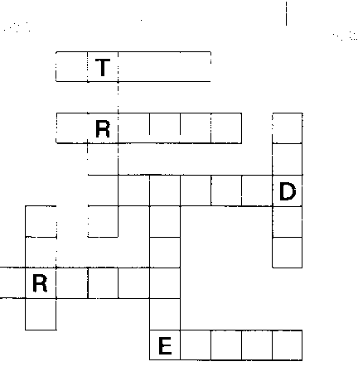

e) Playing Bingo  This involves selecting copying and is an excellent way of revising vocabulary sets (e.g. colours, jobs, clothes, etc.) through a game  Write, with the help of suggestions from the class, 12 – 16 items on the board ( e.g. for clothes: jacket, hat,…) Ask the students to copy any words from the list.  Then read out the words from the list in any order. The first learner to hear his word read out calls out BINGO! | 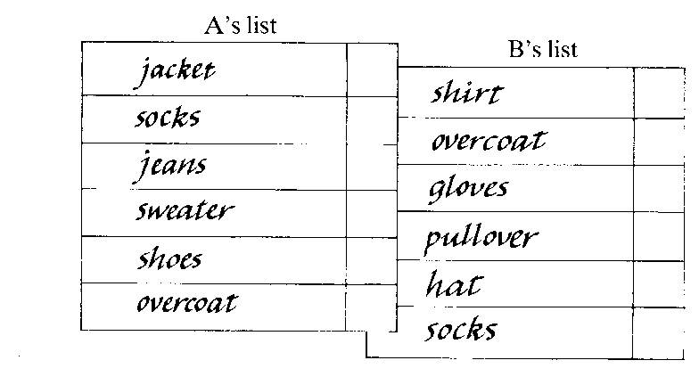
This example is taken from: Donn Byrne: Teaching Writing; Longman 1991

e) Finding the word that is different

The pupils are given a set of 4 – 5 words like those in the diagram and are asked to find and write out the word that is different. This combines reading with writing. Children enjoy the problem-solving aspect of this activity. | 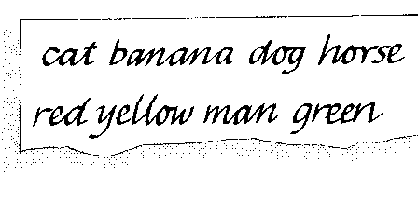

f) Labelling items

For this the pupils use the words listed for them in a box to identify and label, for example, individual objects, people in a group, objects in a scene, etc. | 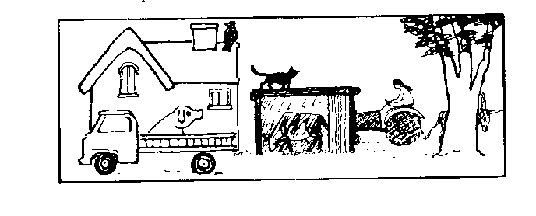  bird, lorry, cat, cow, donkey, house, pig, tractor, tree, woman

g) Finding words

The pupils have to find and write out the words which have been “hidden” in boxes like the one below. The words may belong to a set (e.g. animals, clothes, etc.) and a t a later stage may form a sentence, such as an instruction. The pupils can also make their own word boxes, working individually or in groups, using words which they have been given.

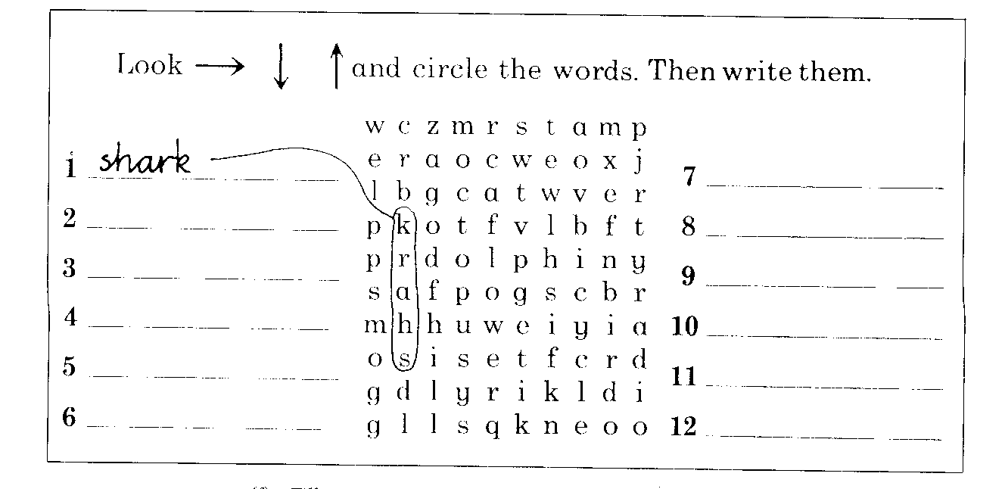

h) Filling in speech bubbles

The pupils have to fill in speech bubbles by matching the sentences with the situation. The activity is more interesting if the pictures form a sequence | 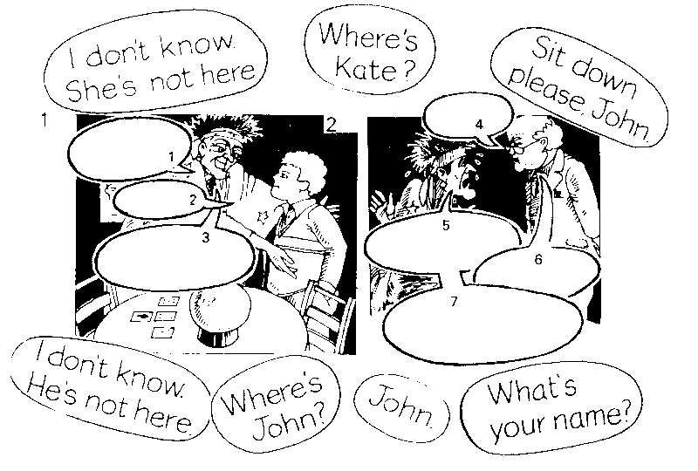

i) Forming dialogues or stories from jumbled sentences
This makes a good pair work or group activity and can be based on something the pupils have already heard.

From these suggestions it should be clear that copying need never be a boring activity! When students copy they actually don’t contribute to the text.

What about a typical classroom situation?
The students are asked to copy from the board or from books – often they are expected to do so without being asked (students who do not write are regarded as extremely off-putting).
Items copied are generally examples of grammatical structures, grammatical rules and items of vocabulary.
Occasionally, students are asked to copy a dialogue or a short narrative from the board for reference.
Many teachers stress the value of a written record of what has been presented in class and the importance of a student vocabulary record.

- Dictations
Dictations typically involve the following steps:
- Teacher reads a short paragraph one or twice at normal speed.
- Teacher reads the paragraph in short phrase units of three or four words each, and each unit is followed by a pause.
- During the pause, students write exactly what they hear.
- Teacher then reads the whole paragraph once more at normal speed so students can check their writing.
- Scoring of students’ written work can utilize a number of rubrics for assigning points. Usually spelling and punctuation errors are considered as severe as grammatical errors.

2. Intensive writing, controlled writing

This type of writing does not allow much, if any, creativity on the part of the writer

Word activities
For the activities in this section the pupil have to provide (i.e. think of and spell the words they need.

The pupils are not given any words. They may, however, be given picture clues (perhaps next to or linked to the relevant squares to be filled in). | 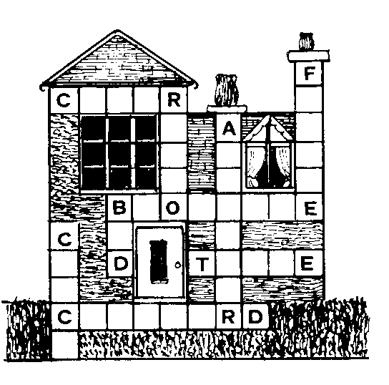

- Labelling items.
The pupils have to provide the words. They can also be asked to draw the pictures needed. For example, they may be asked to label items in a zoo or fridge which they have drawn.

- Making lists
For example, the pupils may be asked to compile lists of:  - things they would like to eat  - countries they would like to visit  - animals they would like to see | 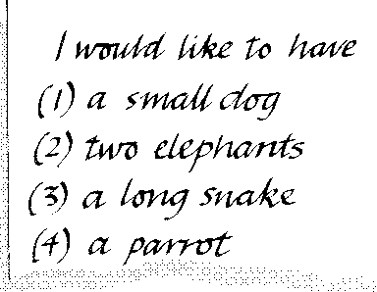
- Classifying items
The pupils have to identify and then arrange in categories (the headings will normally have o be provided or at least worked out with the class beforehand) things they can see in a picture | 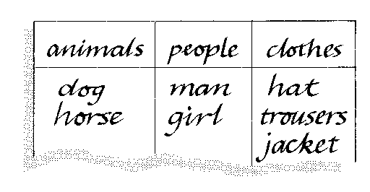
d) Completing texts
That is, the pupils put in the missing words. The texts can be dialogues they have practiced, stories accompanied by a picture sequence or songs, poems and riddles which they have heard (etc.) | 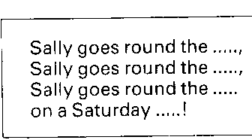
- Correcting sentences or texts
These should be accompanied by a picture so that the pupils are correcting mistakes of fact (not grammar).  For example:  There is a boat in the picture.  There are two boats.  A girls is going home. She’s got a bottle in her hand.  A boy….. | 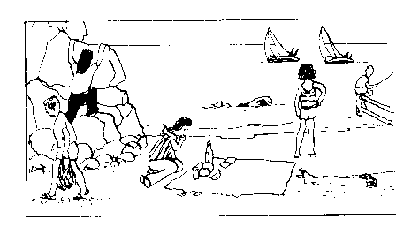

- Making notes
This is particularly important during a game when they may need to keep a record of what objects they have won or which animals they have seen. Usually the items to be noted are words, but sometimes phrases have top be written down. | 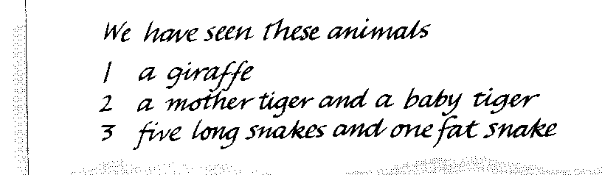
Guided writing
The teacher offers a series of stimulators.

The purpose for these activities is to reinforce key items of structure (often together with a good deal of vocabulary).There is no reason why this kind of manipulative practice need to be boring. Most workbooks provide good activities for this kind of practice, but you may need to supplement this. In any case the suggestions below will help you to see if the workbook has left out any useful areas of activity.

- Writing parallel texts – parallel writing

That is, the pupils have a model and have to write one or more parallel versions.
For this type of activity the students are given a model text of some kind and are asked to write a similar text with the help of cues. These may be verbal as in the first example below or visual as in the second. The text may recycle items of spoken or written language and can be used as an introduction to organising ideas in the form of a paragraph.
The concept of parallel writing suggests that the student should have a model from which to work. In other words students will first see a piece of writing and then use it as a basis for their own work. The original piece that they look at will show them how English is written and guide them towards their own ability to express themselves in written English.

Various ways of reinforcing language learned orally in the early stages are suggested below:
(a) Writing parallel dialogues with the help of keywords
Read this dialogue:
a: Give me that book, please.
b: Which one?
a: The big one — on the table.
b: Here you are!
a: Thanks very much.
Now use these keywords to write similar dialogues:
(a) umbrella/red/behind/armchair
(b) box/small/on top of/cupboard
(c) hammer/heavy/near/window, etc.

More examples of parallel writing:

Example: Read about Switzerland:

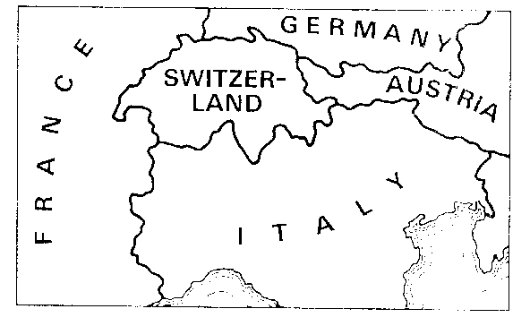  Switzerland is in Europe. It stands between Germany in the north, Austria in the east, Italy in the south and France in the west. About 5½ million people live in Switzerland and they speak French, German and Italian. | - Now write about Austria.  Use these notes:  North: Germany and Czech Republic /  east: Slovakia, Hungary /  south: Slovenia and Italy /  west: Switzerland /  7 million / German

Example: - Hotels

With this stimulating material students have to write descriptions of hotels based on a guide book after first seeing how the symbols are used in a written model. The teacher starts by getting the students to look at the 'Key to symbols' either singly or in pairs. He then finds out if there is any vocabulary the students do not understand. When he is confident that the students understand all the symbols he asks them to study the entry for the Hotel Concorde. He will then ask them comprehension questions to check they have understood the text. If he feels it is necessary he can then elicit similar sentences about, for example, the Castille Hotel as a further check that they can apply the symbols to the model. Students are then asked to write either singly, or in pairs or groups) a similar paragraph about one of the other hotels.
 | It means:  The Hotel Concorde in Paris is a good hotel.  The telephone number is 88-66-21. It is in the city centre.  The hotel is open all year and there are forty bedrooms. There is central heating in the hotel. Breakfast is from seven to nine, lunch is from eleven to three, and dinner is from eight until eleven. There are twenty-five bathrooms and fifteen showers. There is also a swimming pool in the hotel. The nearest railway station is two kilometres away.
  INTERNATIONAL TRAVEL GUIDE: HOTELS |  |  | KEY TO SYMBOLS
  **** | good hotel | B | breakfast
  *** | average hotel | X | lunch
  ** | simple hotel | Y | dinner
  ^ | telephone number | ^ | bathrooms
  ® | city centre | FS | swimming pool
  « | countryside | fl | showers
  o | time of opening | A | railway station
  taf | bedrooms | A | no station
  & | central heating

Now read these symbols, and describe the hotels in
the same way.

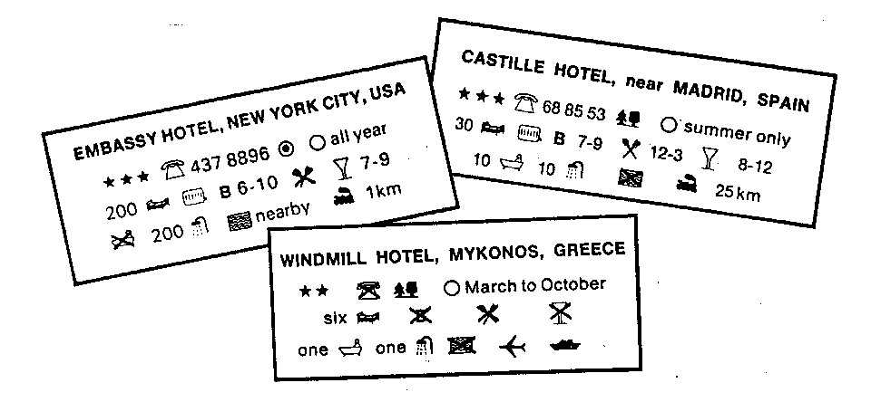

Example: Study and change These texts are taken from ,,THE NEW YOU&ME"
1/5 Text 1 | 1/5 Text 2
I like our school. I am in 1b. We do not wear school uniforms. I like wearing my blue jeans, my red T-shirt and my red and green sweater to school. | Our school is OK. I am in 1 a. I think school uniforms look nice, but in our school we do not wear school uniforms. I like wearing jeans and trainers to school. I do not like wearing skirts.
1/20 Text 1 | 1/20 Text 2
I have a friend, her name is Priscilla Hocus-pocus. She is a magician and she lives in an old tree. I like Priscilla very much. She sometimes turns me into a fish. That's great. I like swimming. | I know a magician. He lives in an old house behind the mountains. He is my best friend. His name is Sylvester Wizz. Sylvester Wizz is a great magician. In his house he has got a big old cupboard. There is a blue, a pink and a yellow bottle in it. When you drink from the blue bottle, you turn into a bird. When you drink from the pink bottle, you turn into an elephant. And when you drink from the yellow bottle, you turn into a crocodile. The yellow bottle is my favourite.

2 / 1 Text 1 | 2/1 Text 2
I stayed at home in the holidays. I played with my friends and I read a lot. I watched a lot of TV too. In the evenings, I sometimes played cards with my mother. | For our holidays, we went to Canterbury, England. My mother has friends there. We went to London by plane. Then we went to Canterbury by train. My mother's friends have a nice house there with a big garden. I often played table tennis in the garden with some English children. That was great fun.
3/6 Text 1 | 3/6 Text 2
I don't care about clothes very much. I think it's stupid to buy expensive clothes. I've got plenty of T-shirts, trainers and sweaters. Why should I buy more? It doesn't matter what you wear. It is important to feel OK in your clothes. I feel best in jeans and T-shirts. | \ sometimes envy Thomas. He always wears the latest fashion: T-shirts, trainers, sweaters, trousers, jeans. And all them are new. I usually wear hand-me-downs from my brother. I hate wearing hand-me-downs. With my first money I make, I'll buy lots of clothes. I think clothes are important.

The following example is taken from: Creative Grammar Practice by G. Gerngroß and Herbert Puchta
I'D LIKE TO BE Lead-in activities
Noun study
1. Hand out a copy of the following words to each of your students and allow them fifteen seconds to study it.
Butterfly | snowman | rainbow | snowflake
sports car | helicopter | pizza | pilot
Teacher | tiger | elephant | piano
diamond ring | wind | Eagle | mineral
Knife | friend | flower | insect
Policeman | river | pudding | ice cream
Snake | leaf | fairy | witch
Word | ball | tennis racket | storybook
Shark | rainbow | surfboard | cheesecake
2. Ask them to put their papers face down on their desks.

Noun collection
1. In pairs students write down as many of the words as they can remember. Allow about two minutes for this.
2. Ask them to shout out the words. Write them on the board.

Associations and dissociations
1. Ask each pair to choose one noun from the list and note down at least three adjectives that they associate with it plus at least one adjective they think has nothing at all to do with it. Give a few examples:
ball: red, big, lovely (associations) /stupid (disassociation)

2. Ask pairs to read out their words. Note them on the board in two different colours.
Comparatives and superlatives
- Next comes a quick response exercise. One student starts by calling out a classmate's name and one of the adjectives from the board.
- The student called has to quickly say the comparative and the superlative. If right, erase that adjective from the board. If not, leave it until someone else gets both the comparative and superlative correct.
- Continue until all the adjectives on the board have been erased.

Presentation of model text

Display the following on OHP or poster paper.

MODELTEXT

The most colourful butterfly
The sweetest cheesecake
The most beautiful tiger
The smallest snowflake
The fattest caterpillar
and the most dangerous snowman.
These are what I would like to be.

Text creation

Students write their own texts using bilingual dictionaries.
The following text was written by a twelve-year-old in her second year of learning English.
The most expensive ring,
the softest teddy bear,
the nicest rainbow,
the most colourful surfboard,
the biggest pizza
and the nicest teacher.
These are what I would like to

- Sentence linking activities

Our goal through this type of activity is to begin to familiarize the students with the cohesive devices which are used in composing a text. They can then begin to combine structures which they have learned orally to form an acceptable sequence in writing. For this purpose, in order to make any headway, it will be necessary to introduce a selected number of linking devices and to practise these through writing. A basic kit at this stage might consist of the following:

Coordinators and, but, or, so
Conjunctions although, when, until, so that (etc.)
Sequencers then, after that, meanwhile, first, next, finally
Linkers moreover, however, therefore, as a result, in fact, of course, on the other hand, etc.

Some procedures for practising these are suggested below. Although this should normally be done within the context of a text, such as a letter, this does not preclude some initial practice for the purpose of familiarizing the students with linking sentences, as in the first example below.

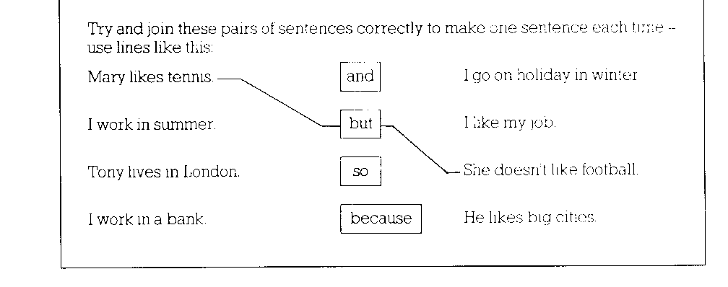
The students then have to write four true sentences about themselves.

(b) The students complete a short text, using suitable linking words or phrases from a given list.
For example:
Complete the letter below. Use suitable words or phrases from this box:

although  also | and  because | by the way  however | so that  that
and | but | so | that

Notice that exercises¹ like these, in the form of a complete text, also serve to introduce the student to such points as the layout of a letter, different modes of address and salutation, etc. Examples of these should be written up on the board and the students asked to copy them into their notebooks for reference. It is important, therefore, to incorporate a range of such features which will be useful to the students when they themselves are asked to write letters (as communication tasks, for example). | 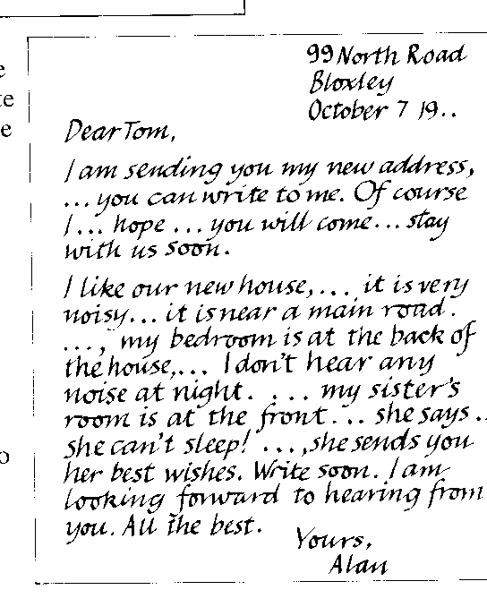

- Completing speech bubbles
The pupils now have to supply the sentences for themselves.

- Writing sentence sequences

This is a device for getting the pupils to write sentences using the same structure. For example, they use the days of the week to write about themselves or perhaps a character from their course book. | 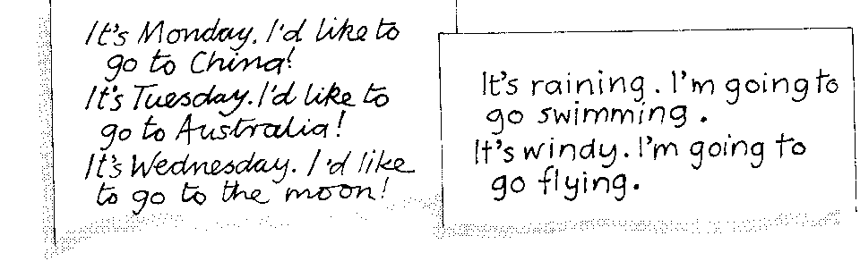
Although this involves repetition, there is always room for imagination!

- Compiling information

For this activity the pupils have to write some sentences which provide information, for example, about one of the characters in the course book or about a topic. | 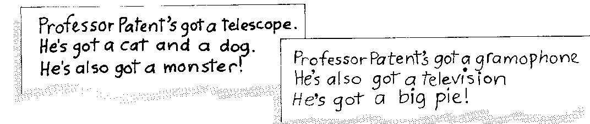  It often involves repetition of a structure and may be done with reference to a picture.

- Writing/completing questionnaires

For this the pupils work with questionnaires that have been prepared for them. It can be a useful way of disguising some very basic question practice. The pupils can of course use such questionnaires to question one another. | 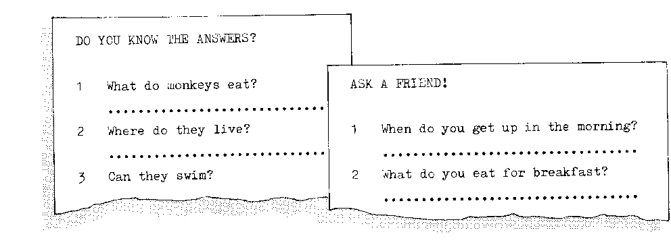

g) Reconstructing a model text

Reconstructing a model text can be done in spoken or written form. It is the process of eliciting from the students as accurately as possible the text presented to them earlier.
The rationale of this stage is like this: by remembering the model text the students can experience a feeling of success and gain ability in using the words and structures accurately.

* Skeleton texts
Only the first letters of each word is given
Text A
Model text:
Do you really mind me spending every Saturday at a football match?
Do you really mind me spending the evenings tinkering with my motor bike?
Do you really mind me smoking like a chimney?
Do you really mind me getting drunk one a while?
Well, then we’ll have to say good-bye because I do mind intolerant people.

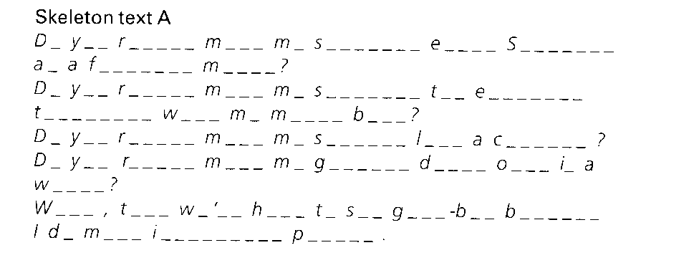
(taken from G. Gerngroß and H. Puchta: Creative Grammar Practice; 1994, page 39)
Another version of a skeleton text
Model text  I was awful.  When she heard that word  She fell right back into that old trap  Of disliking herself,  Of feeling guilty,  Of wanting to creep into a mouse-hole,  Of taking back what she had said.  She was her old self again. | Skeleton text  It was ___________________.  When _____________________  ______________ fell right back into that old trap  of _________,  of _________,  of _________,  _____was _____old _____ self again.

Jumbled texts

Model text  The big car moved silently down the road.  I quickly hid behind the bushes.  The car stopped and a man slowly got out.  The doorbell of the dark house rang loudly.  A man and a woman began to talk angrily.  Then a shot rang out suddenly.  I saw the man’s hat gently rolling away. | Jumbled text  The doorbell of the dark house rang loudly.  I saw the man’s hat gently rolling away.  The car stopped and a man slowly got out.  The big car moved silently down the road.  Then a shot rang out suddenly.  I quickly hid behind the bushes.  A man and a woman began to talk angrily.

- Answering questions
The students have read a text, watched a video, or listened to a CD. The teachers asks the students to write down the answers to some questions:
Where does the story take place?
What do you know about….?
What does he say to the woman in the car?

- Dicto-comp
A paragraph is read at normal speed; then the teacher puts the key words from the paragraph, in sequence, on the blackboard and asks students to rewrite the paragraph from the best of their recollection of the reading, using the words on the board.

- Self –writing
It’s writing with only the self in mind as an audience.

  - Making notes

This is similar to keeping records while playing a game. Many activities involve keeping some kind of record in the form of a list. For example, the pupils can be asked to write down, in sentence form, the differences between two pictures or the number of mistakes they can find in the picture.

  - Recoding personal information

Young learners like talking about writing about themselves | 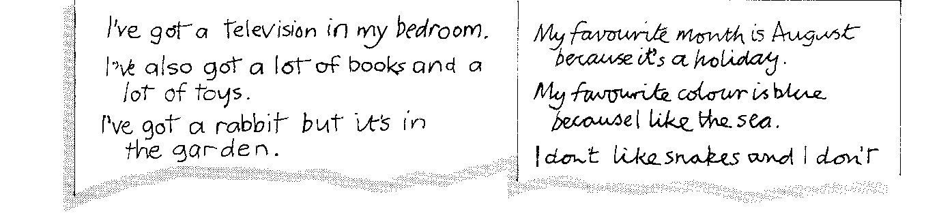
and they will very happily write down personal data (names, age, address, family details, hobbies, etc.) or make lists of their possessions or likes or dislikes

  - Writing notes
.
Pupils write to one another in class. This is a key activity for young learners because it gets them to write quickly. They send and answer notes.  The pupils can:  - ask for something ( e.g. a coloured pencil which another pupil has in front of him)  - ask for some personal information  ask about a character in a course book, etc. | 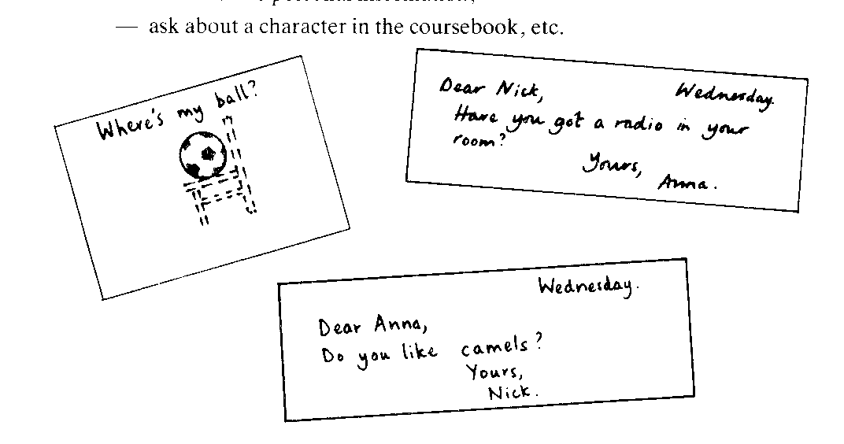

Creative writing activities

Pupils need plenty of opportunities to use language imaginatively. Unlike many older learners, they are always willing to show you their work and to ask 'Can I say this?", so that fewer mistakes occur than might be expected. Let pupils work together in pairs or small groups wherever possible.

(a) Writing notes
For this activity, give them tasks that will require longer sequences. For example:

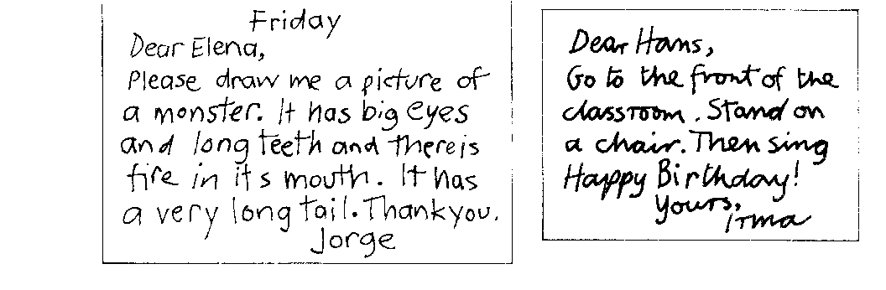

(b) Writing about pictures
Choose pictures that will encourage the pupils to use fantasy and rehearse the idea orally first so that they understand the kind of thing you want. Pupils can also draw pictures for one another to write about.

(c) Writing role cards
The pupils can ask someone to be a character from the course book or an animal!
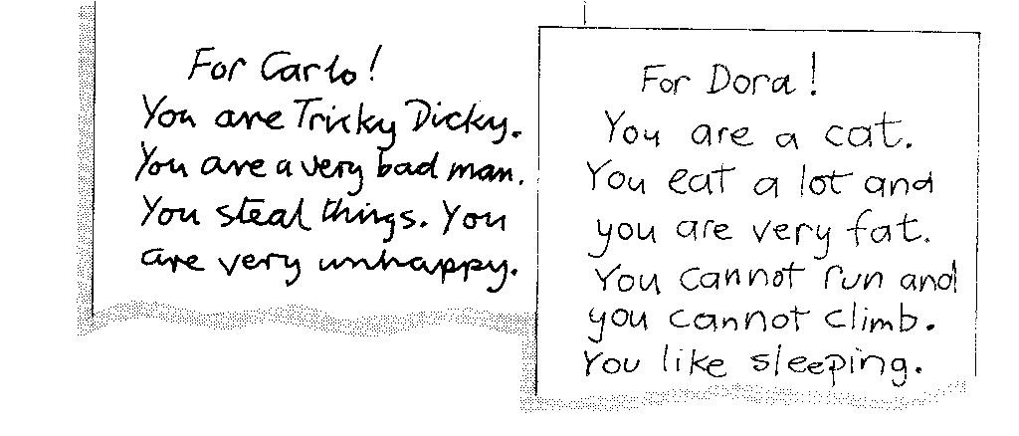

(d) Making up stories
You can start by asking the pupils to write short dialogues, with two speakers, which they should then cut up and give to another group to piece together. Then let them try their hand at very-simple stories (5-6 sentences), which they should also cut up for another group to piece together.

(e) Writing notices
You can give the pupils small picture cards for this activity or let them use their own ideas (i.e. they may prefer to write about things they would actually like or things they have). Children very often like to exchange things so the activity can be authentic. The pupils can also write rules and regulations for their classroom, for example, or for a club or recreation park.
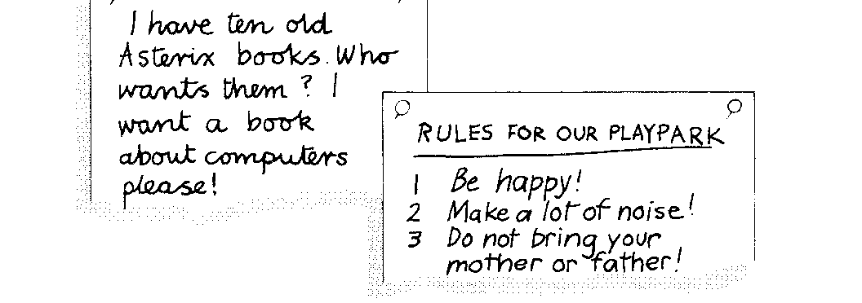

(f) Writing book reports
When the pupils have reached the stage of using class readers — or even looking through them — they can be asked to write 2-3 sentence 'reports' on them. The reports should he pasted at the hack of the book for other pupils to read.
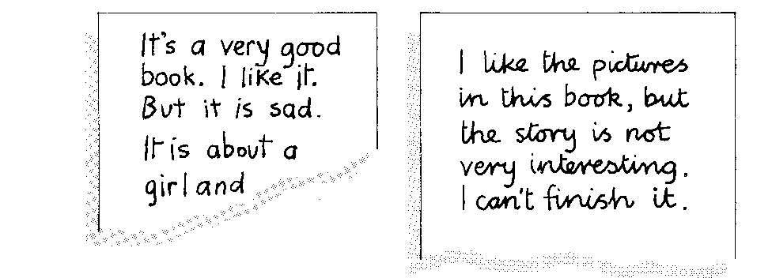

(g) Writing messages
The pupils will happily enter into writing messages from other strange places: the moon, the bottom of the sea, a balloon, the middle of the desert, etc.

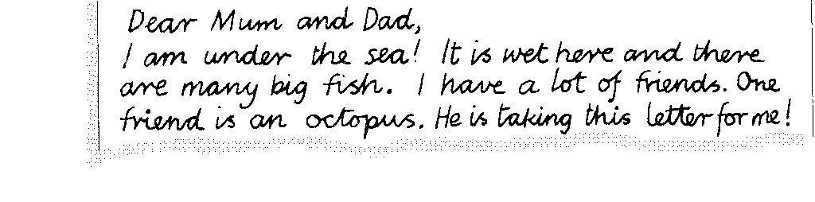

(h) Project work
One useful and enjoyable project for learners at this age is to get them to make their own picture dictionaries. The pupils can work on their own or in groups (even if they work in groups, so as to help one another, they may like to make their own copy). For the dictionary, they will need an exercise book. They can draw their own pictures or cut suitable ones out of magazines. The intention is not to get them to keep a record of all or even many of the words they have learnt but only to write about items that interest them. They should \\rite sentences about their words (not definitions) and from time to time go back and add to what they have written.
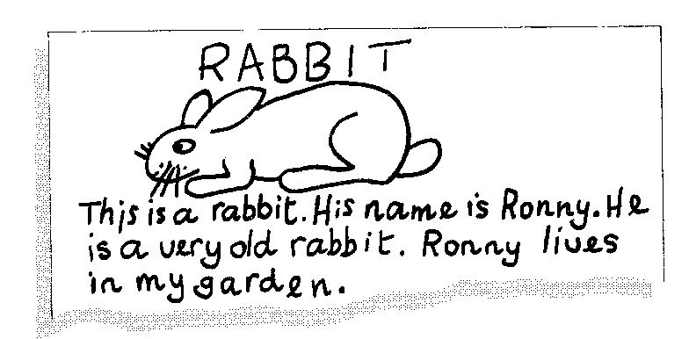

Most pupils also enjoy making a class wall sheet, which will provide a focus for a number of writing activities, e.g. little stories, captions and balloons for pictures, jokes and riddles (etc.). Both the picture dictionary and the wall sheet should be spread over a school year.

    - Note taking
Students take notes during a lesson for the purpose of later recall.
Note taking also can be done in the margins of a book or on old craps of paper.

